
Château de la Baudonnière – Fire Evacuation Procedures for ‘Designated Fire Officer/Officers’

In the interests of enhancing your children’s safety in relation to the efficient evacuation of your dormitory blocks in the event of the Château fire alarm sounding, we respectfully request that the following procedures are followed:
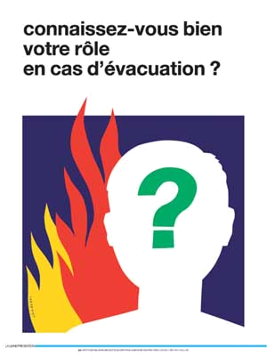
- Each school is advised to designate a supervising adult or adults from your party as a fire officer or officers for each of your dormitory blocks throughout your visit.

- The designated officer or officers should ensure that the children staying in their dormitory block are aware of the situation of fire exits and of how to correctly evacuate their building should a fire alarm sound. Fire officers should also familiarise themselves with the location of ‘break glass’ alarm points and extinguishers.

- On hearing the alarm sound the designated officer or officers should ensure that their building is evacuated in the correct manner and, if no danger is posed to them, he/she should throw back duvet covers, check under beds and in cupboards, wardrobes, toilets and bathrooms to make sure no person is left behind.

- Once the designated fire officer or officers is happy that their building is clear, he/she should report to the central fire assembly point with the fire list from the entrance to their building and count their children. Once everyone has been counted you should stay at that point and organise one of your colleagues to alert the Château Duty Manager. It is also a great help if you can keep the children in straight lines and quiet and calm. If at any time the fire assembly point becomes unsafe then you should move to the field in front of the Château.

We thank you in advance for your cooperation in helping us to ensure your stay with us is safe as well as enjoyable.

