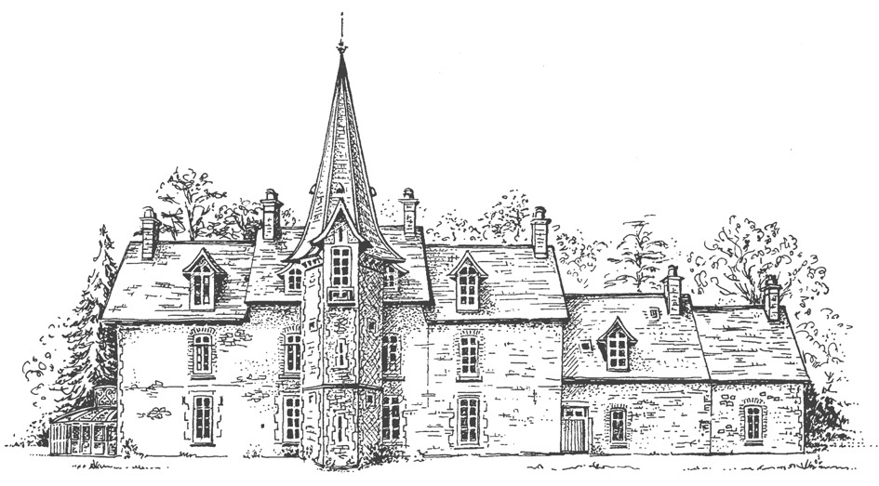

Climbing Equipment

Monthly Safety Checks

Slings

 |  |  |  | Date of Monthly Safety Check
Unique  ID  Number | Date of Manufacture | Date Introduced | Manufacturers Retirement Date
Key  OK = Ok Condition  M = Monitor (to be recorded overleaf)  R = Retired |  |  | Inspected BY

